Exercise 08:
Questions:
- A group of 150 college students were asked to indicate their most liked film star from six different well known film actors namely A,B,C,D,E and F in order to ascertain their popularity. The observed data were as follows:
Actors | A | B | C | D | E | F
Frequencies | 24 | 20 | 32 | 25 | 28 | 21

Test at 5% whether all actors are equally popular.
- The surface finish of products produced in a machine shop is suspected to be affected by factors operator and machine. The data of this experiment with two replications in different treatment combinations are summarized in the given table. Analyze and check the significance of components of the related model when significance level is 0.05

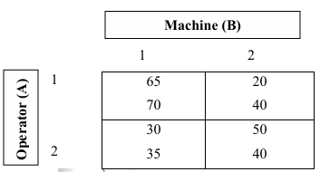

- An oil company was interested in testing four different blends of gasoline for fuel efficiency by controlling the variability of four different drivers and four models of cars. The fuel efficiency was measured as kilometre per litre after driving the cars over a standard clause. Analyze the data and write the inference based on the results. [given F(0.05) ] =4.76 for (3,6) df].
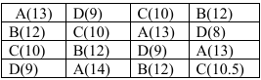

- A factory produces items with a defect rate of 2%. If a sample of 50 items is selected, calculate the probability of finding exactly 3 defective items.
- The number of customer arrivals at a service desk follows a distribution with a mean of 5 per hour. What is the probability that exactly 7 customers will arrive in the next hour?
- A clinical trial involves 100 patients, where the probability of side effects from a medication is 0.01. Using an appropriate distribution, estimate the probability that more than 2 patients will experience side effects. Justify your choice of distribution.
- A company claims that the mean lifetime of its batteries is 100 hours. A sample of 25 batteries has a mean lifetime of 98 hours with a standard deviation of 5 hours. Perform a one-sample T-test to evaluate the company's claim at a 5% significance level.
Solution:

